|  |  |  |  |  |
| --- | --- | --- | --- | --- |
| **National University of Computer and Emerging Sciences, Lahore Campus** | | | | |
| C:\Users\saif\AppData\Local\Microsoft\Windows\Temporary Internet Files\Content.Word\final design.jpg | **Course:** | **ITC** | **Course Code:** |  |
| **Program:** | **BS(Computer Science)** | **Semester:** | **Fall 2016** |
| **Duration:** | **150 Minutes** | **Total Marks:** | 30 |
| **Paper Date:** | **25-Oct-16** | **Weight** |  |
| **Section:** | **A1 & A2** | **Page(s):** | **2** |
| **Exam:** | **Midterm** |  |  |
| **Instruction/Notes:** | All question carries 5 Marks. 5*6 = 30 | | | |

**Problem 1:** Write a C++ program of a Body Mass Index (BMI) calculator application that reads the user’s weight and height and then calculates and displays the user’s body mass index. The formula for calculating BMI is:

|  |
| --- |
| English BMI Formula |
| BMI = ( Weight in Pounds / ( Height in inches x Height in inches ) ) x 703 |
| Metric BMI Formula |
| BMI = ( Weight in Kilograms / ( Height in Meters x Height in Meters ) ) |

Also, the application should display the following information from the scale provided below.

BMI VALUES Underweight: less than 18.5; Normal: between 18.5 and 24.9; Overweight: between 25 and 29.9; Obese: 30 or greater

Note: Your program should check that the height and weight entered are not negative. If the entered data is incorrect display a message accordingly.

**Problem 2:** In a right triangle, the square of the length of one side is equal to the sum of the squares of the length of the other two sides. Write a C++ program that takes in lengths of the three sides of a triangle, and then outputs whether the triangle is right or not.

**Problem 3:**

An Armstrong number of three digits is an integer such that the sum of the cubes of its digits is equal to the number itself. For example, 371 is an Armstrong number since 3*3*3 + 7*7*7 + 1*1*1 = 371.Write a program to find all Armstrong number in the range of 0 and 999.

**Problem 4:**

Write a program in which the user has to enter all numbers between 5 and 25 (inclusive). If the user does not enter the correct number, display an error and ask to enter again. For example:

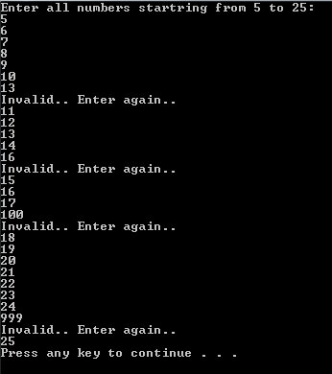

**Problem 5:**

Design and write a C++ program that takes as input an integer larger than 1 and calculates the sum of the squares from 1 to that integer. The output should be the value of the squares and the sum, properly labelled on the screen.

For example, if the integer equals 4, your program would display “1 + 4 + 9 + 16 = 30”

**Problem 6**: Write a function which takes 5 numbers from user and prints them in reverse order (reverse of the order in which they were taken). For example if user enters 1, 2, 3, 4, 5 your program will display following on the screen:

|  |
| --- |
| Elements in reverse order:  5  4  3  2  1 |

**Bonus Question :**  Write a function which takes 5 numbers in array1, copies them in array2, updates array2 by saving square of each number and displays both arrays (Make sure you implement all the requirements in separate loops i.e. 1st loop for input, 2nd for copying data, 3rd for saving square and 4th for display). Sample output is given below:

|  |
| --- |
| Array1 Array2  4 16  9 81  7 49  2 4  5 25 |

Now run your program on 10 numbers.